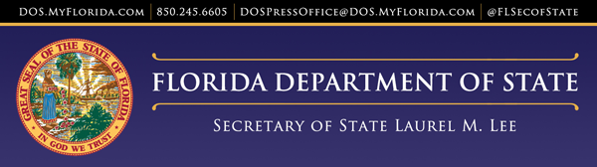
For Immediate Release
Friday, July 30, 2021
Contact: Mark Ard
850-245-6522
Mark.Ard@dos.myflorida.com

Secretary of State Laurel M. Lee Announces the Two Regimes Exhibition at the Gallery for Innovation and the Arts
TALLAHASSEE, FLA. –
Secretary of State Laurel M. Lee invites the public to view the exhibition “Two Regimes” which tells the life story of a Ukrainian mother and her daughter from 1927 to 1945 in Western Europe.

“I am honored to invite the public to this exhibition. This powerful exhibition tells the true and powerful story of a family’s survival under the two regimes of Stalin and Hitler,” said Secretary Lee. “In this remarkable memoir, Two Regimes brings Teodora Verbitskaya’s writings and Nadia Werbitzky paintings together for future generations. It offers the opportunity for open discussion on the impacts of war on families then and now.”

The manuscripts of Teodora Verbitskaya are brought to life by the paintings of her daughter, Nadia Werbitzky. Together, they represent the lives of Ukrainians, Jews, Greeks, and others who lost their lives during this tragic period in world history. After liberation from a forced labor camp by United States soldiers in 1945, Verbitskaya and Werbitzky immigrated to Canada. Nadia Werbitzky later spent several years of her life painting in Florida.
The exhibit is on view in the Gallery for Innovation and the Arts on the first floor of the R. A. Gray Building until September 30, 2021.

About The Gallery for Innovation and the Arts
The Gallery for Innovation & the Arts is dedicated to showcasing Florida artwork that is educational and demonstrates inventive ways of using visual media to convey new ideas and highlight often unheard voices.

The exhibit space is located on the first floor of the R. A. Gray Building at 500 South Bronough Street. Normal hours are Monday – Friday, 9:00 am to 4:30 pm, Saturday 10:00 am to 4:30 pm, and Sunday Noon – 4:30 pm.

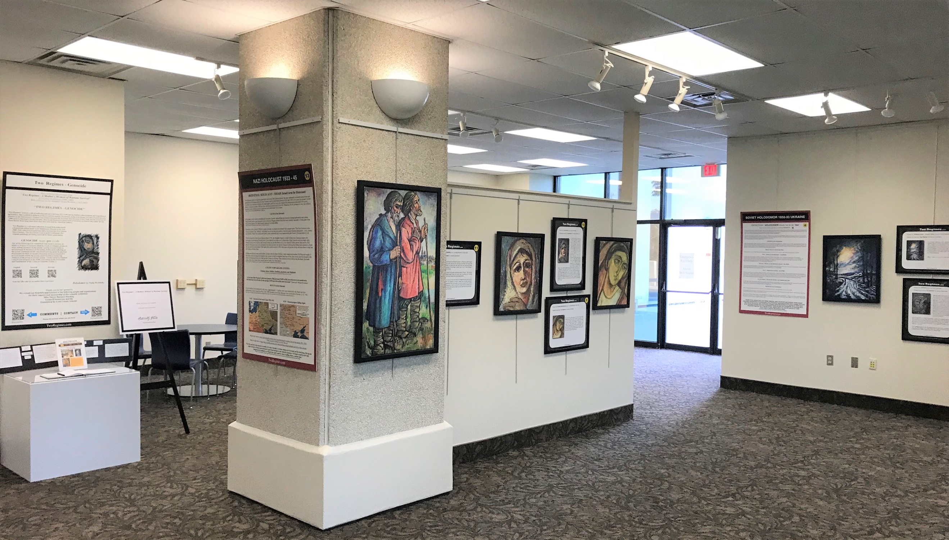

For more information on the Capitol Complex Exhibition program and the Division of Cultural Affairs, please visit: https://dos.myflorida.com/cultural/

###

Source: https://dos.myflorida.com/communications/press-releases/2021/secretary-of-state-laurel-m-lee-announces-the-two-regimes-exhibition-at-the-gallery-for-innovation-and-the-arts/

