National Infantry Museum, Columbus, GA

Mother's, daughter's work comes together

12:15 PM, Sep 6, 2012 |

Comments

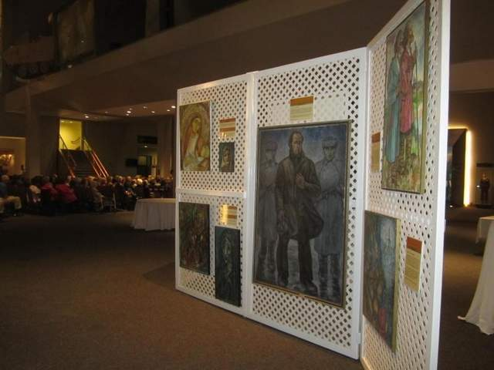

The art of Nadia Werbitzky has only been exhibited five time in the United States. / Special to the Chronicle

Written by

Mimi Shaw

Special to the Chronicle

- Filed Under
- Chronicle
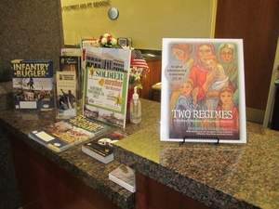
Zoom

Two Regimes... A Mothers Memoir of War Time Survival / Special to the Chronicle
The artwork of Nadia Werbitzky and the manuscript of her mother (Teodora Verbitskaya), both deceased, were found underneath a house not far from Tallahassee Florida. These termite eaten artifacts were sold at an estate sale 12 years ago to Perry and Mimi Shaw and Kelly Bowen of Tallahassee.
The now interpreted Russian manuscript of the mother (deceased over 40 years) and the master artistry of her daughter have been consolidated into book form- to unite the life’s works of these two Ukrainian artists, decades apart. The book is entitled "Two Regimes... A Mothers Memoir of War Time Survival."
Nadia Werbitzky was born in the Soviet Union where she experienced deprivation and starvation under the Soviet regime. In 1942, her family was deported to Germany where they were confined to labor camps until the end of the war. Nadia studied at the Meisterschulle of Cologne and the Art Academy of Dusseldorf before moving to Toronto where she met and married and American Diplomat. The couple traveled extensively throughout Europe allowing Nadia to study the works of the Great Maters. Her painting "Eternal Motherhood” won first prize at Frankfurt’s International Art Show in 1973.
The art of Nadia Werbitzky has only been exhibited five time in the United States. Currently there are 19 oil pieces- relevant to the Holocaust on exhibition along with the availability of the book itself at the National Infantry Museum, in Columbus Georgia.
Much of the art is being restored by local artist and historical military miniature expert Michael Hall of Dragoon Miniatures fame. Michael has restored eight of the Werbitzky collection to date.
Last weekend the art had its opening at the Judge Cohn Holocaust exhibit dedication within the World Power annex of the National Infantry Museum and people from all over the world were drawn to the beautiful and humble art that depicts people and the narration of the human condition at that time.
The collection will remain on loan to the National Infantry Museum in Columbus for an indefinite time period. More information on the book and the educational programs for K-12 that are being developed for the entire collection with the sanction of the Florida Department of Education who has sent out official email notices to all schools endorsing the book as a Florida resource for teachers.
Please go to wwwTwoRegimes.com for more information and/or to purchase a book for $15.95.

http://www.tallahassee.com/apps/pbcs.dll/article?AID=2012309130007

